MODULE -2 :-

SQL PROBLEMS :-

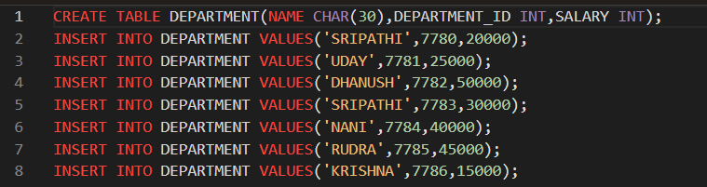

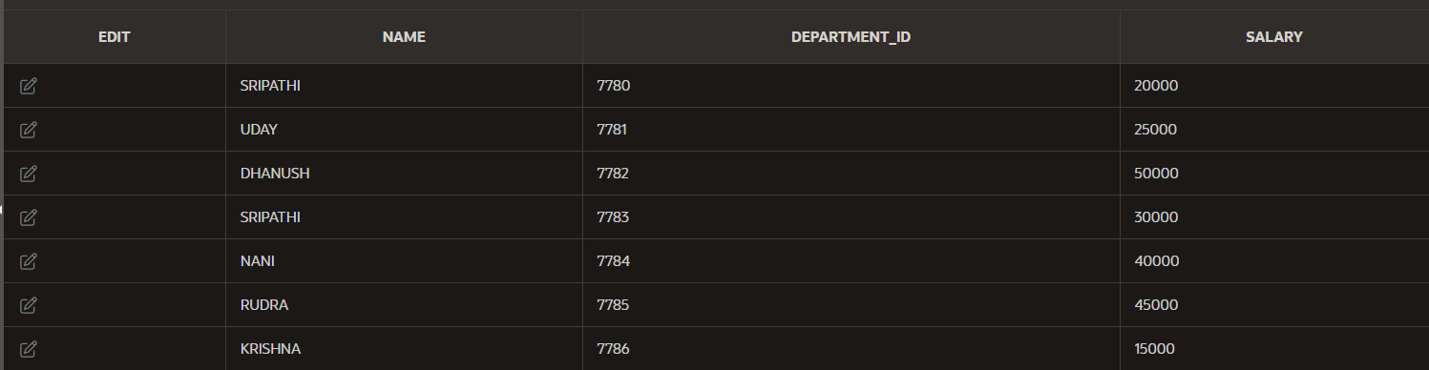

MAX VALUE





MIN VALUE :-





SUM VALUE :-





AVG VALUE :-





COUNT VALUES :-





ROUND(AVG(SALARY)) :-

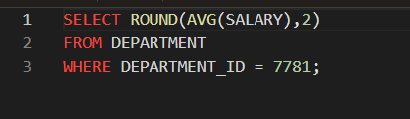

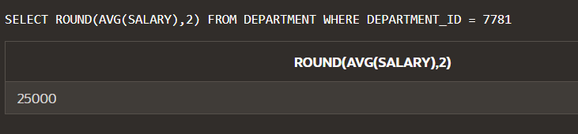

VARIANCE :-

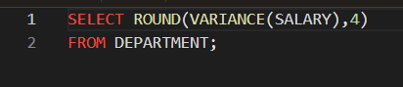

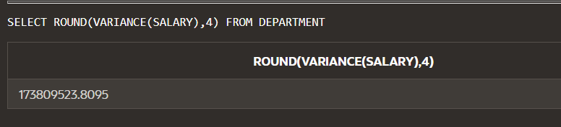

STDDEV :-

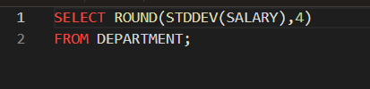



MORE THAN ONE GROUP FUNCTION :-





DP_8_sg.pdf :-

COUNT :-

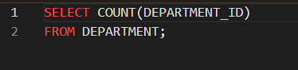



RETURN ALL NAMES :-



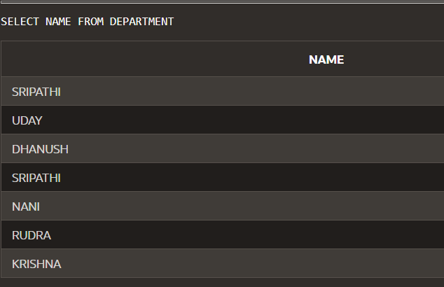

USING DISTINCT :-



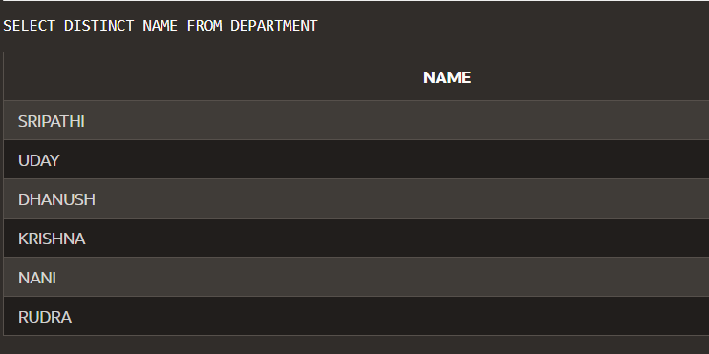

USING DISTINCT SUM :-

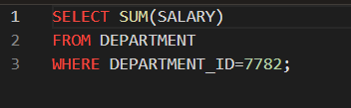



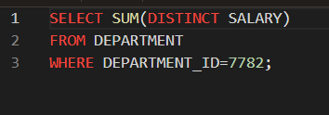

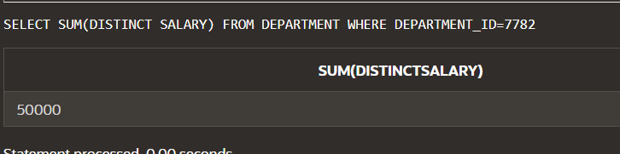

DISTINCT AND COUNT

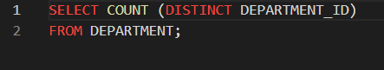

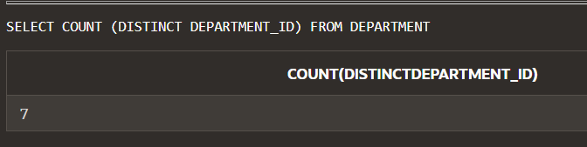

NVL

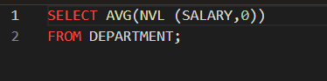

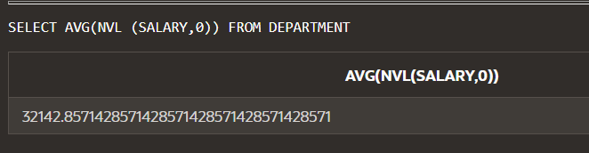

9-1 USING GROUP BY AND HAVING CLAUSES

GROUP BY USE :-

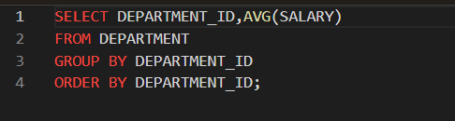

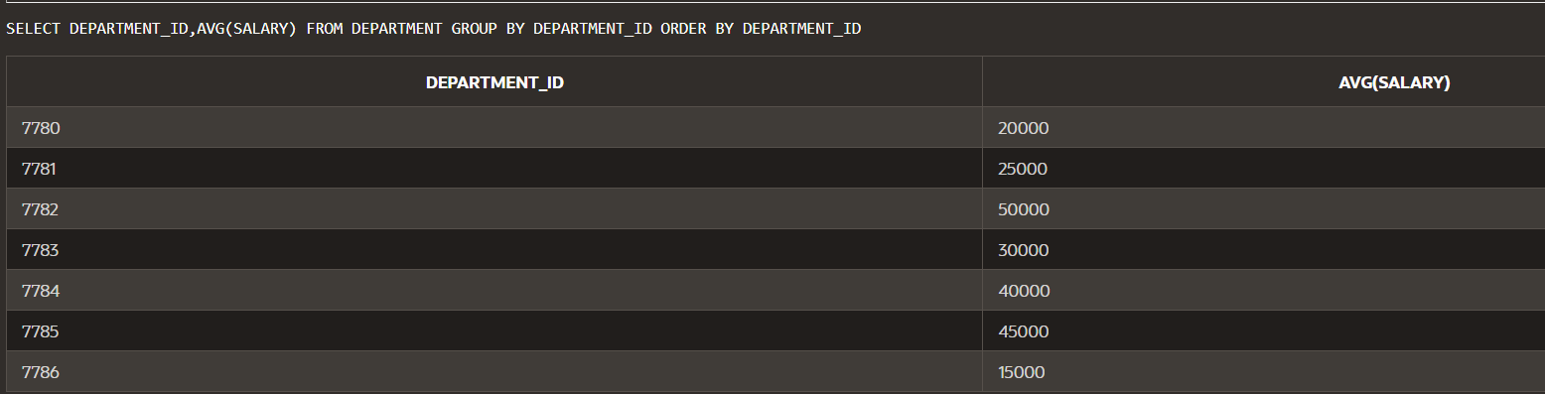

MAXIMUM SALARY OF EMPLOYEES IN EACH DEPARTMENT :-



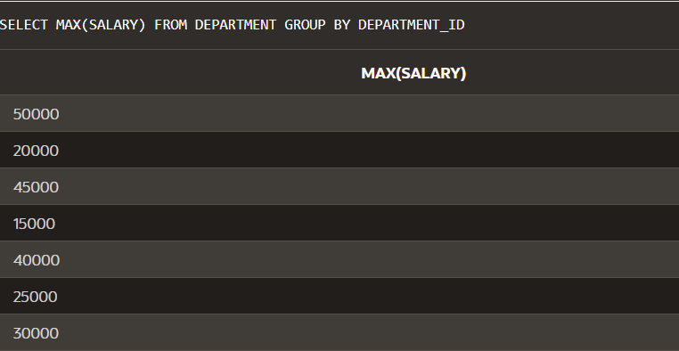

GROUP BY IN SELECT :-



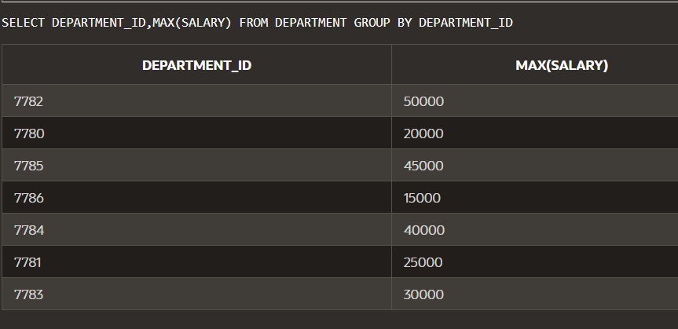

GROUP BY CLAUSE

COUNT :-

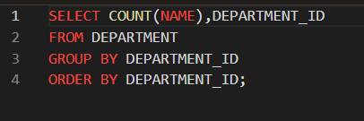

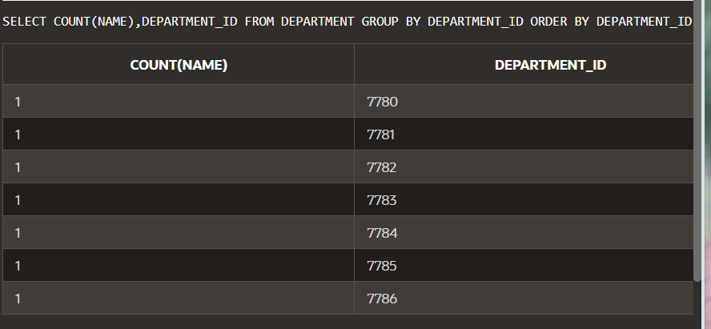

QUERY USING COUNT(*) :-

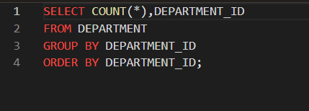

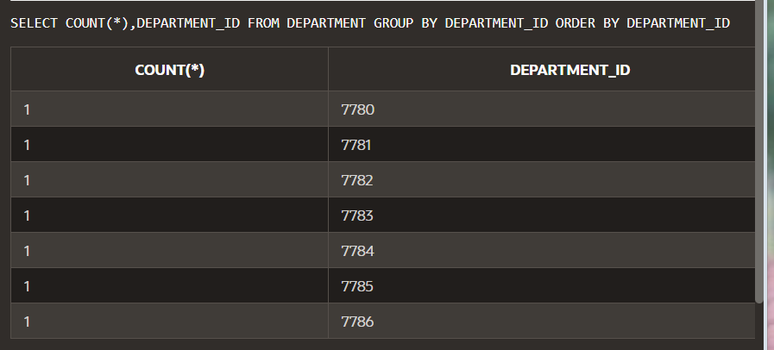

WHERE CLAUSE :-

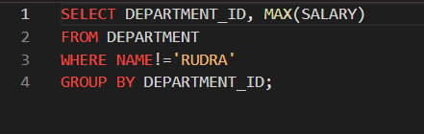

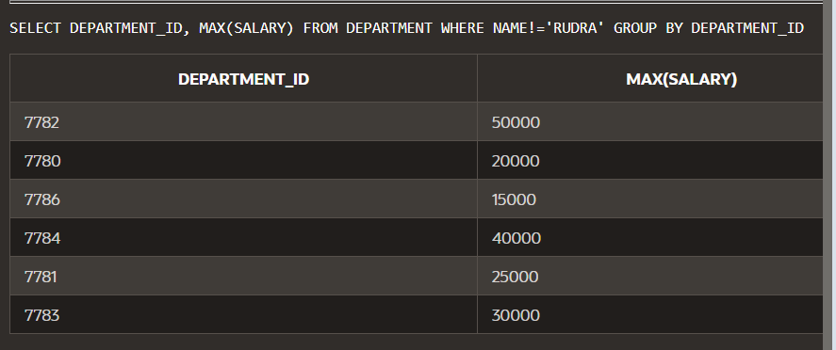

GROUPS WITHIN GROUPS :-

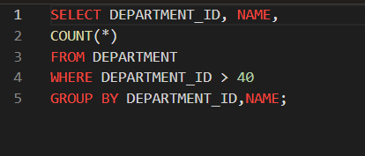

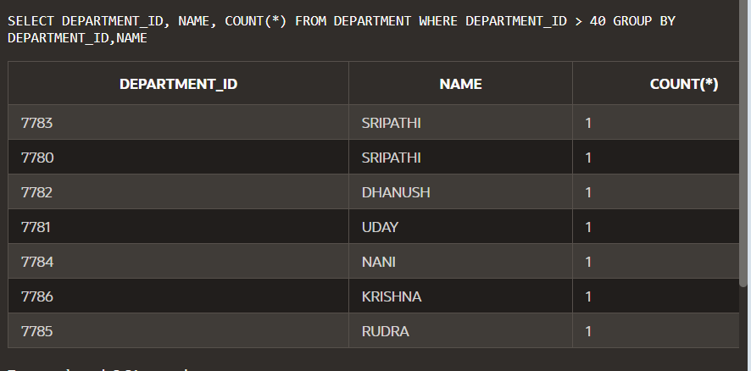

NESTING GROUP FUNCTIONS :-

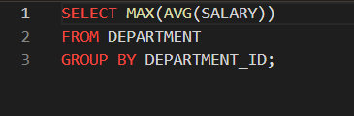



HAVING :-

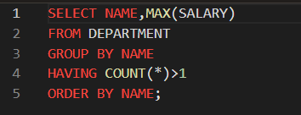

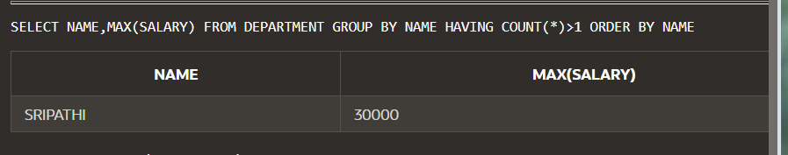

AVERAGE SALARY OF THE EACH DEPARTMENT :-

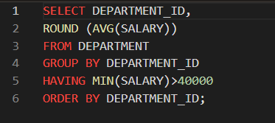

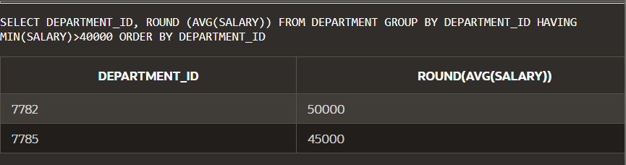

9_2 USING ROLLUP AND CUBE OPERATIONS AND GROUPING SETS

ROLLUP :-

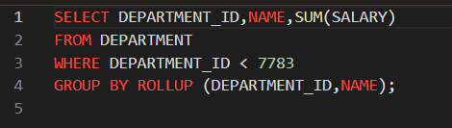

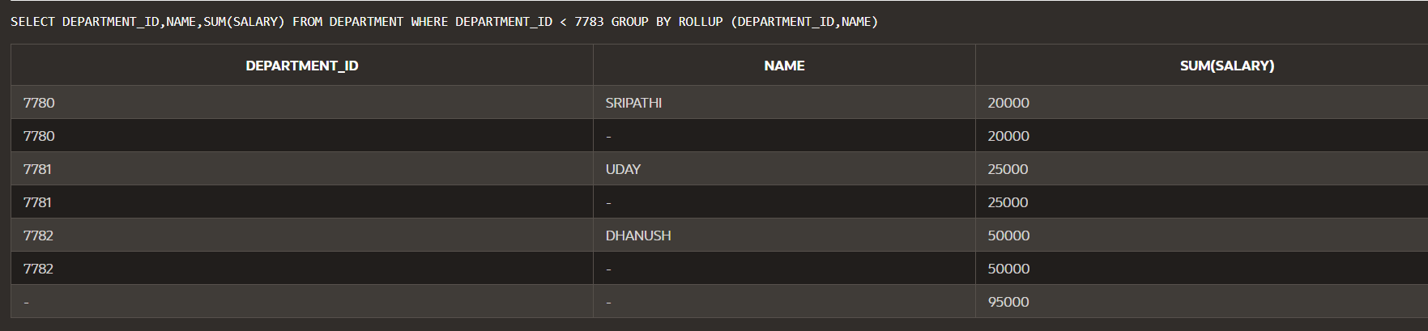

WITHOUT ROLLUP :-

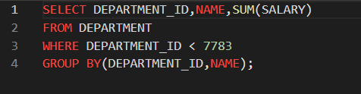

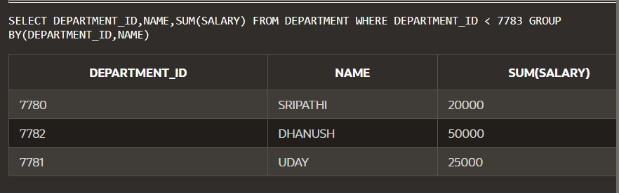

CUBE :-

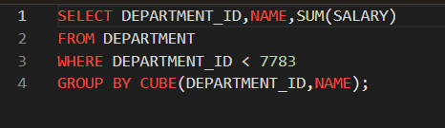

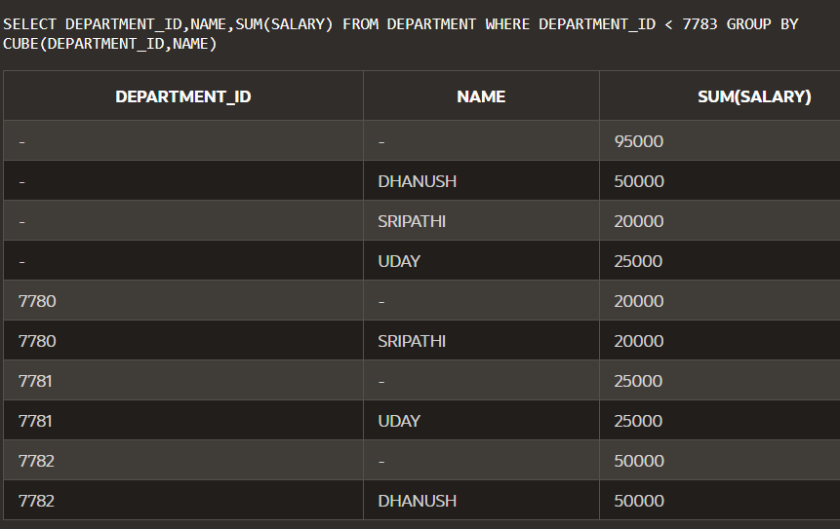

GROUPING SETS :-

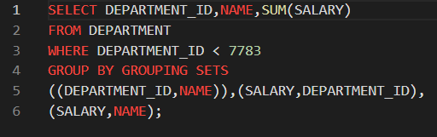

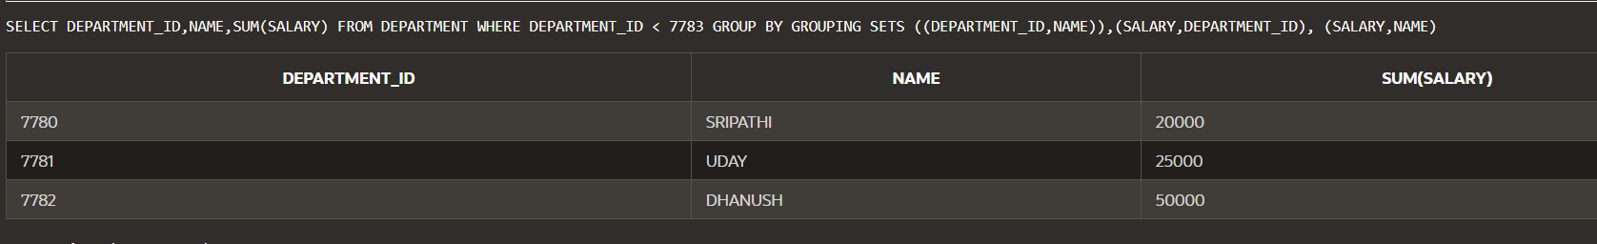

GROUPING FUNCTIONS :-

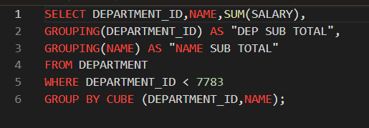

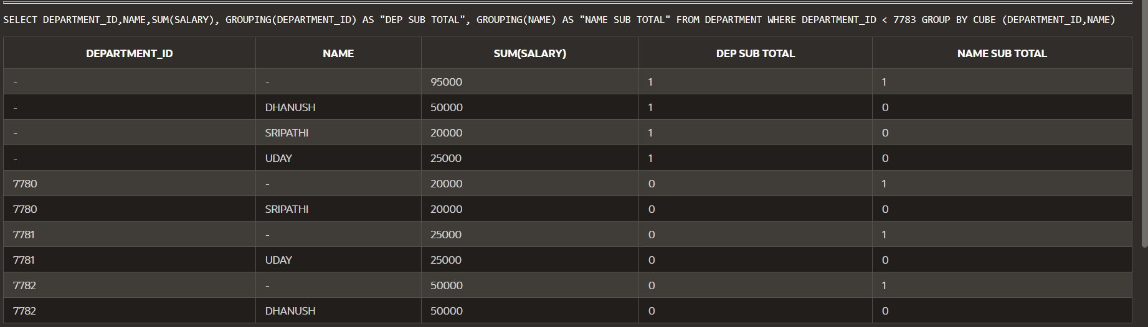

9-3

USING SET OPERATORS

UNION :-

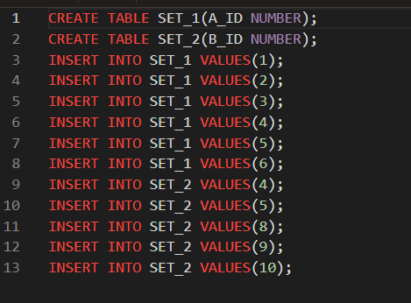





UNION :-

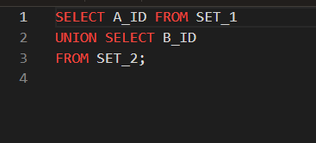

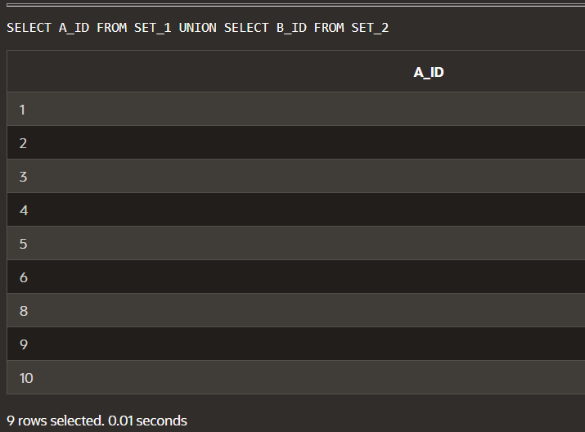

UNION ALL :-

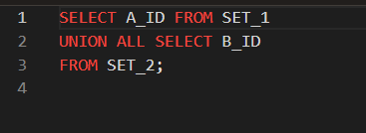

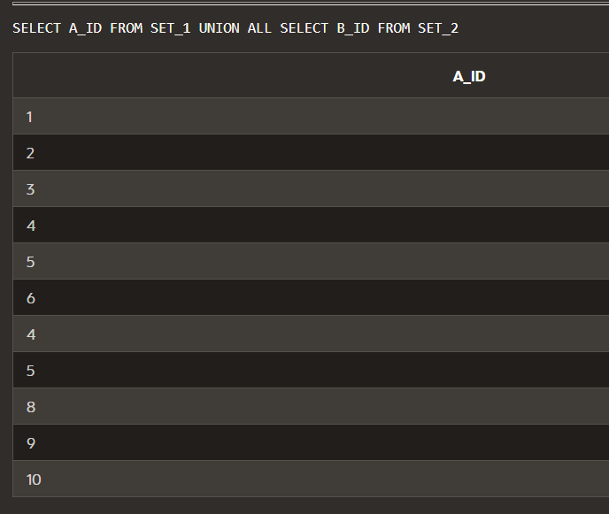

INTERSECT :-

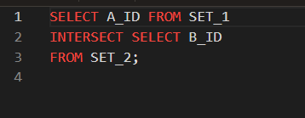

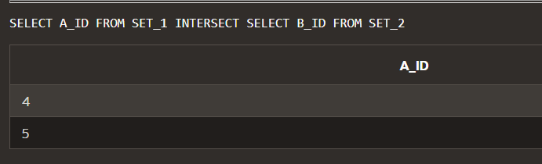

MINUS :-

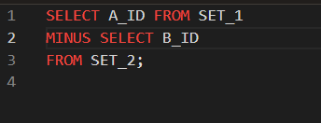

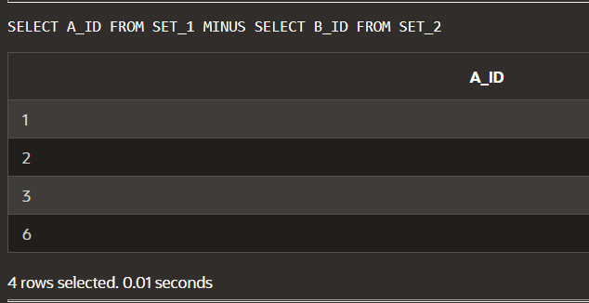

SET OPERATOR :-

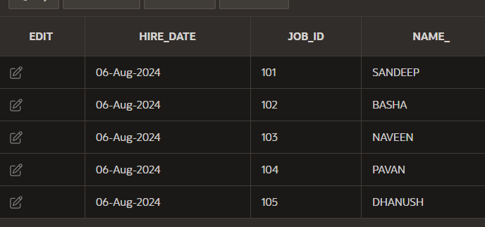

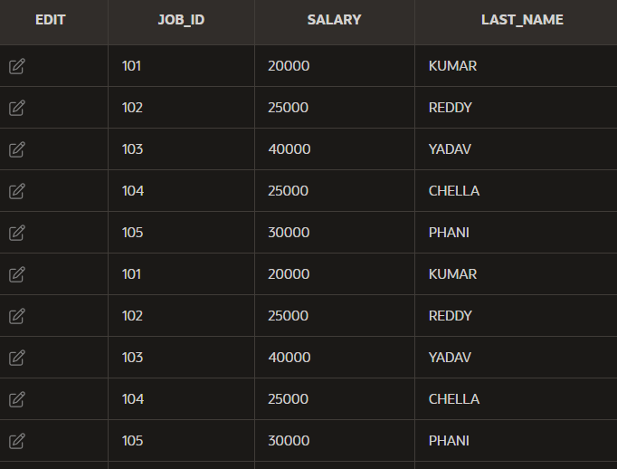

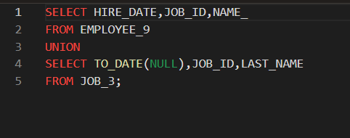

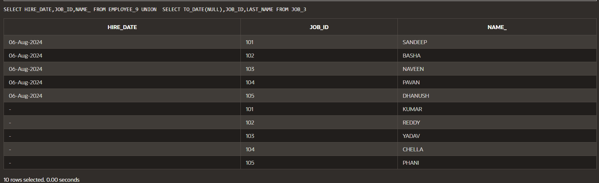

ORDER BY :-

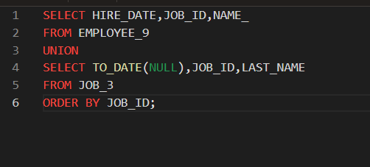

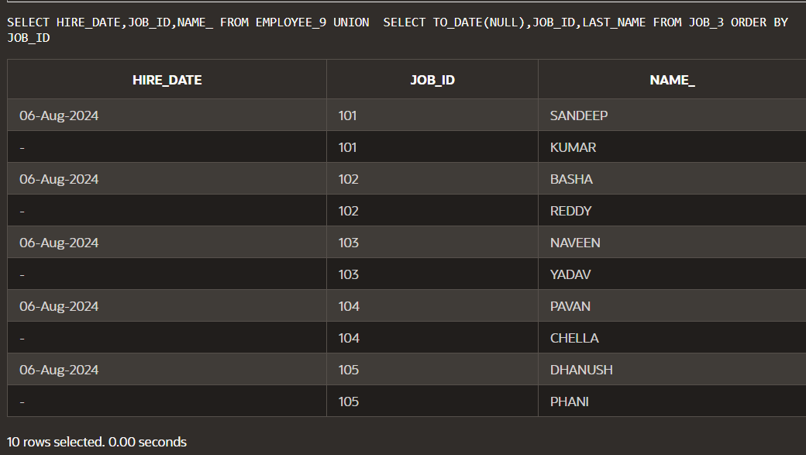

SET OPERATIONS ORDER BY :-

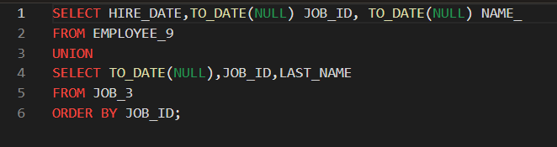

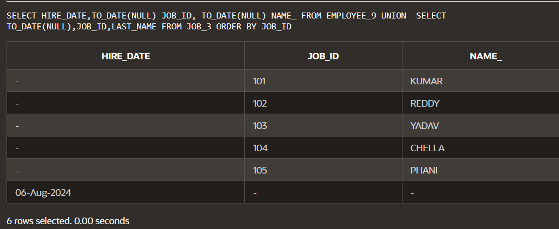

SUBQUERY :-

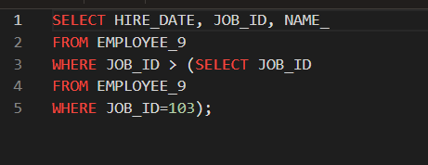

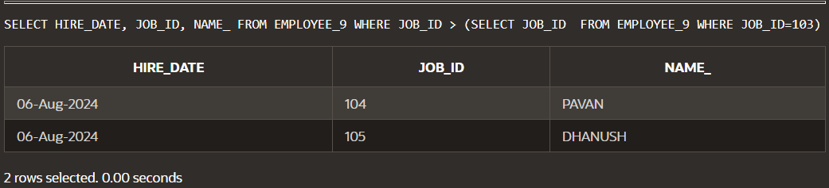

SUBQUERY AND NUL :-

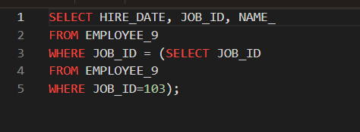

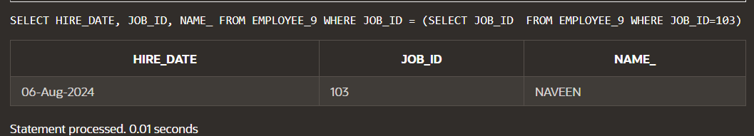

20-1

ENSURING QUALITY QUERY RESULTS- ADVANCED TECHNIQUES

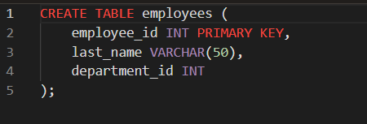

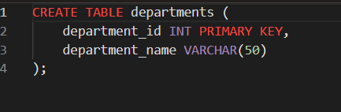

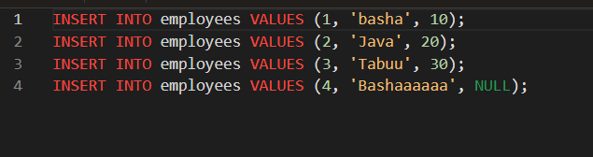



SELECT TABLE :-

